Chapter 6: The Link Layer and LANs
Roadmap
- Introduction to the Link Layer
- Error Detection and Correction
- Multiple Access Protocols
- Local Area Networks (LANs)
  - Addressing (MAC) and ARP
  - Ethernet
  - Switches
  - VLANs
- Link Virtualization: MPLS
- Data Center Networking
- A Day in the Life of a Web Request

1. Introduction to the Link Layer
- Primary Responsibility: The link layer is responsible for transferring a datagram from one node to a physically adjacent node over a single link. Hop – Hop Delivery

Link Layer: Context
- A datagram is transferred by different link protocols over different links in its path (e.g., WiFi on the first link, Ethernet on the next).
- Each link protocol may offer different services (e.g., some provide reliable data transfer, others do not).

Transportation Analogy
- Trip: Princeton to Lausanne
- Mappings:
  - Tourist = Datagram
  - Transport Segment = Communication Link
  - Transportation Mode = Link Layer Protocol
  - Travel Agent = Routing Algorithm

Link Layer: Services
The link layer provides several key services:
- Framing & Link Access:
  - datagram into a frame
  - channel access if the medium is shared.
  - Uses MAC addresses to identify the source and destination nodes on the link.
- Reliable Delivery:
  - Provides reliable data transfer between adjacent nodes.
  - This is seldom used on low-error links (like fiber) but is common on high-error links (like wireless).

- Flow Control:
  - pacing between adjacent sending and receiving nodes
- Error Detection:
  - Detects errors caused by signal attenuation or noise.
  - The receiver may signal for retransmission or simply drop the corrupted frame.
- Error Correction:
  - The receiver identifies and corrects bit errors without needing a retransmission.
- Duplex Modes:
  - Half-duplex: Nodes at both ends can transmit, but not at the same time.
  - Full duplex: Nodes at both ends can transmit and receive simultaneously.

Host Link-Layer Implementation
- The link layer is implemented in every host.
- It is typically found on a Network Interface Card (NIC) or built directly onto the motherboard chipset.
- The NIC implements both the link and physical layers.
- It attaches to the host's system bus.
- Implementation is a combination of hardware, software, and firmware.

Interfaces Communicating
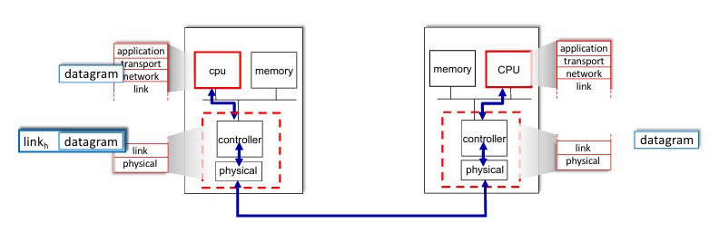
- Sending Side:
  - Encapsulates the datagram (from the network layer) into a frame.
  - Adds error-checking bits, RDT, flow control information, etc., as per the protocol.
  - Passes the frame to the physical layer.
- Receiving Side:
  - Receives the frame from the physical layer.
  - Looks for errors, performs RDT, and flow control checks.
  - If the frame is valid, it extracts the datagram.
  - Passes the datagram up to the network layer.
2.Error Detection
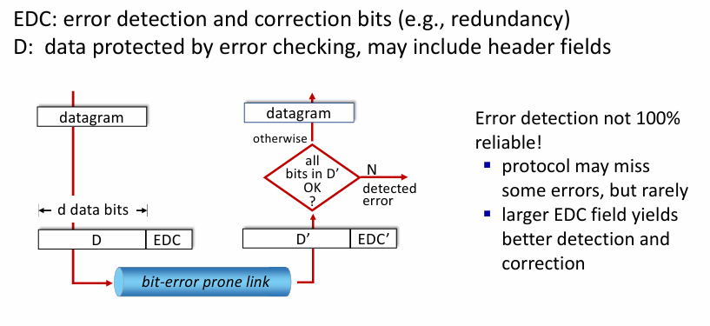
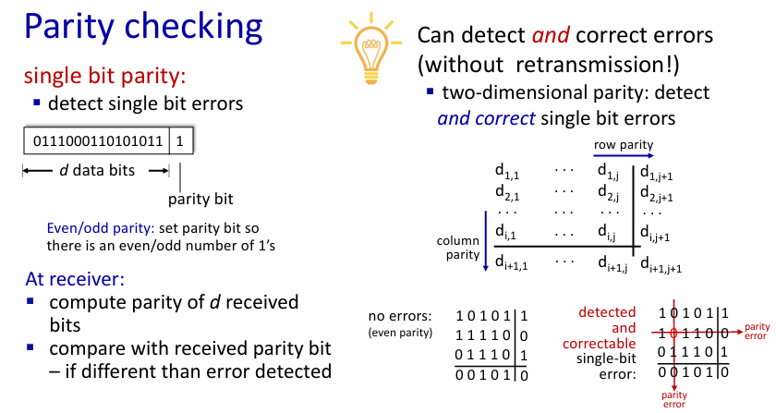
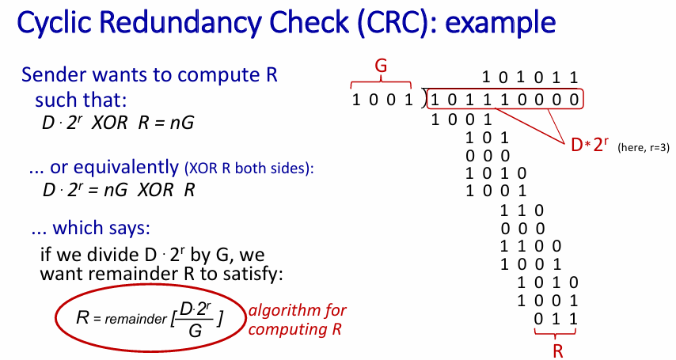

3. Multiple Access Links and Protocols
1. Types of Links
- Point-to-Point: (e.g., Ethernet switch to a host, dial-up PPP).
- Broadcast (Shared Medium): A single channel shared by two or more nodes.
  - Simultaneous transmissions cause interference, known as a collision.
  - Examples: Old-school Ethernet, upstream HFC (cable), 802.11 WiFi, satellite.
2. The Multiple Access Problem
- Goal: Create a distributed algorithm (a Multiple Access Control, or MAC, protocol) to determine how nodes share the channel and decide when to transmit.
- Challenge: All coordination must happen using the channel itself (no separate, out-of-band channel).
3. Ideal MAC Protocol Desiderata
Given a shared channel of rate R bps:
- Single Node: One node can transmit at the full rate R.
- M Nodes: M nodes can each transmit at an average rate of R/M.
- Decentralized: No special "master" node is needed for coordination, and no clock synchronization is required.
- Simple: The protocol is easy to implement.

MAC Protocol Taxonomy
There are three broad classes of MAC protocols:
- Channel Partitioning:
- Random Access:
- "Taking Turns":

1. Channel Partitioning Protocols
TDMA (Time Division Multiple Access)
- Access to the channel is divided into "rounds."
- Each round is divided into fixed-length time slots.
- Each station is assigned a specific slot in every round.
- Problem: Unused slots go idle, wasting bandwidth.
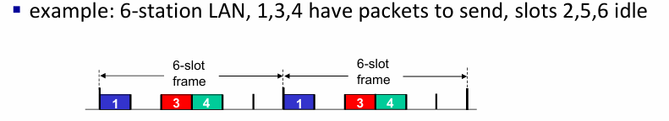
FDMA (Frequency Division Multiple Access)
- The channel's frequency spectrum is divided into smaller frequency bands.
- Each station is assigned a fixed frequency band.
- Problem: Unused transmission time within a frequency band goes idle.
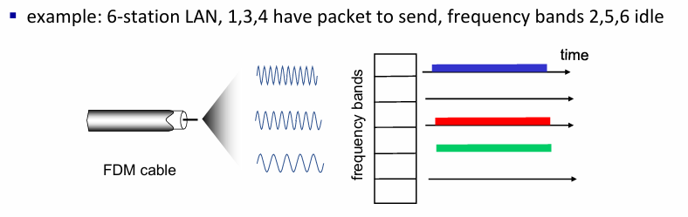

2. Random Access Protocols
- Nodes transmit at the full channel rate R when they have a packet.
- No a priori coordination before transmission.
- A "collision" occurs if two or more nodes transmit at the same time.
- The protocol specifies:
  - How to detect collisions.
  - How to recover from collisions (usually via delayed retransmissions).
- Examples: ALOHA, Slotted ALOHA, CSMA, CSMA/CD, CSMA/CA.
Slotted ALOHA
- Assumptions:
  - All frames are the same size.
  - Time is divided into equal-sized slots (time to transmit one frame).
  - Nodes are synchronized and only begin transmitting at the start of a slot.
- Operation:
  - When a node has a frame, it transmits in the next available slot.
  - If no collision (Success): The node can send a new frame in the next slot.
  - If collision: The node retransmits the frame in each subsequent slot with a probability p until it succeeds.
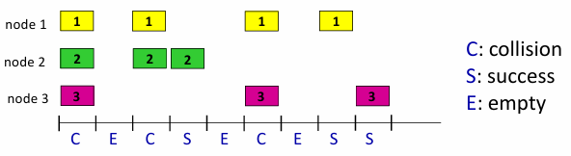
- Pros:
  - A single active node can use the full channel rate R.
  - Simple and highly decentralized.
- Cons:
  - Collisions waste slots.
  - Idle slots are wasted.
  - Requires clock synchronization.
- Efficiency:
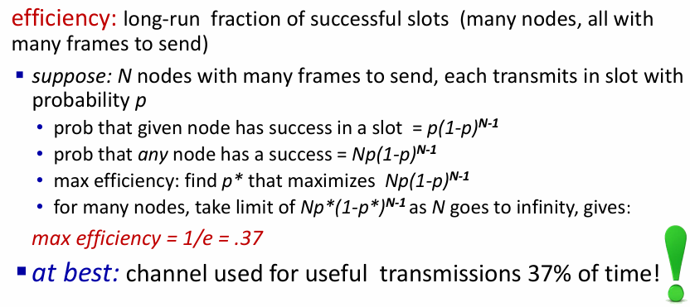
CSMA (Carrier Sense Multiple Access)
- Principle: "Listen before transmit."
- If the channel is sensed idle, transmit the entire frame.
- If the channel is sensed busy, defer transmission.
- Problem: Collisions can still occur due to propagation delay. (Two nodes may both sense the channel as idle, transmit, and only later hear each other's signal).
CSMA/CD (CSMA with Collision Detection)
- An enhancement to CSMA, famously used in Ethernet.
- Key Idea: While transmitting, a node also listens. If it detects another signal, it knows a collision has occurred.
- Ethernet CSMA/CD algorithm
  - Ethernet receives datagram from network layer, creates frame
  - If Ethernet senses channel: if idle: start frame transmission. if busy: wait until channel idle, then transmit
  - If entire frame transmitted without collision - done!
  - If another transmission detected while sending: abort, send jam signal
  - After aborting, enter binary (exponential) backoff:
    - after mth collision, chooses K at random from {0,1,2, …, 2^m -1}. Ethernet waits K·512 bit times, returns to Step 2
    - more collisions: longer backoff interval

3. "Taking Turns" Protocols
These protocols try to get the efficiency of random access at low load and the fairness of partitioning at high load.
- Polling
  - A centralized controller (master) "invites" (polls) each node, one by one, to transmit.
  - Concerns: Polling overhead, latency, and a single point of failure (the master).
  - Used by Bluetooth.
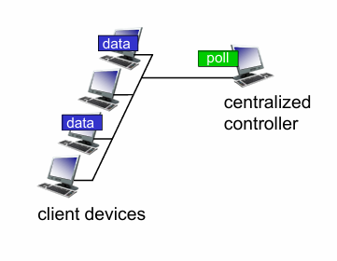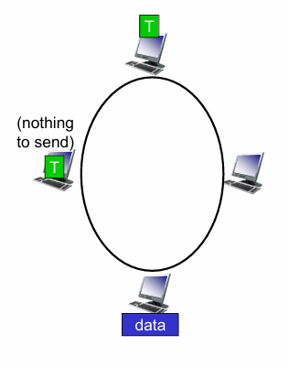
- Token Passing
  - A special control message (the token) is passed sequentially from one node to the next.
  - A node can only transmit if it is currently holding the token.
  - Concerns: Token overhead, latency (waiting for the token), and a single point of failure (if the token is lost).

Hybrid Example: Cable Access Networks (DOCSIS)
Cable networks use a mix of all three protocol types:
- FDM: The cable spectrum is divided into (downstream) TV channels and (upstream/downstream) data channels.
- Downstream (Headend to Modems): This is a broadcast channel.
- Upstream (Modems to Headend):
  - The CMTS (Cable Modem Termination System) assigns some upstream time slots to specific modems (TDM / Partitioning).
  - The CMTS leaves other slots open for contention. Modems use Random Access (with binary backoff) in these slots to request future data slots.

4. LANs
- Addressing, ARP
- MAC Address (Layer 2):
  - A 48-bit, link-layer address.
  - Also known as a LAN, physical, or Ethernet address (e.g., 1A-2F-BB-76-09-AD).
  - Function: Used "locally" to move a frame from one interface to another physically connected interface (i.e., on the same subnet).
  - Properties:
    - Represented as 6 pairs of hexadecimal digits.
    - Burned into the Network Interface Card (NIC) ROM.
    - Globally unique, with allocation administered by the IEEE.

ARP: Address Resolution Protocol
- The Problem: How does a node (Host A) find the destination MAC address of another node (Host B) on the same subnet, knowing only Host B's IP address?
- The Solution: ARP.
- ARP Table:
  - Every node (hosts and routers) on a LAN maintains an ARP table.
  - This table is a cache of IP-to-MAC address mappings.
  - Entries look like: <IP address; MAC address; TTL>.
  - TTL (Time to Live): The time after which an entry is deleted (e.g., 20 minutes), forcing a new ARP request if needed.
ARP Protocol in Action
This is how Host A finds Host B's MAC address:
- ARP Query (Broadcast):
  - Host A sees B's MAC is not in its ARP table.
  - A constructs an ARP query frame with the message: "Who has IP address IP_B?"
  - A sends this frame to the broadcast MAC address: FF-FF-FF-FF-FF-FF.
- Reception by All Nodes:
  - Every node on the LAN receives and processes the broadcast query.
  - All nodes except B see the target IP (IP_B) is not theirs, so they drop the packet.
- ARP Response (Unicast):
  - Host B recognizes its own IP address in the query.
  - B replies with an ARP response frame sent directly (unicast) to MAC_A.
  - The message is: "I am IP_B, and my MAC address is MAC_B."
- Caching:
  - Host A receives the response from B.
  - A adds the mapping (IP_B $\rightarrow$ MAC_B) to its ARP table.
  - A can now send its original IP datagram to B, placing it in a frame with the destination MAC_B.

Routing to Another Subnet

- Key Concept: The IP addresses (final source and destination) never change during the datagram's journey. The MAC addresses (local source and destination) change at every hop.
- Scenario: Host A (IP_A, MAC_A) wants to send a datagram to Host B (IP_B, MAC_B) on a different subnet, via Router R.
- At Host A (Subnet 1):
  - A creates the IP datagram.
    - IP Source: IP_A
    - IP Destination: IP_B
  - A knows the datagram is not for the local subnet, so it must send it to its default router (Router R).
  - A creates a Layer 2 frame to send the datagram to the router. (It uses ARP to find MAC_R if needed).
    - MAC Source: MAC_A
    - MAC Destination: MAC_R (the router's MAC on Subnet 1)
- At Router R (Receiving):
  - R's interface on Subnet 1 receives the frame (it's addressed to MAC_R).
  - R de-encapsulates (removes) the frame, finds the IP datagram inside, and passes it "up" to its IP (network) layer.
- At Router R (Forwarding):
  - R's network layer looks at the datagram's IP Destination: IP_B.
  - It performs a routing lookup and determines it must send the packet out on its other interface (the one connected to Subnet 2).
  - R re-encapsulates the original, unchanged IP datagram into a new frame.
    - IP Source: IP_A (unchanged)
    - IP Destination: IP_B (unchanged)
    - New MAC Source: MAC_R_iface2 (R's MAC on Subnet 2)
    - New MAC Destination: MAC_B (R uses ARP on Subnet 2 to find this)
  - R sends this new frame onto Subnet 2.
- At Host B (Subnet 2):
  - Host B's NIC receives the frame (it's addressed to MAC_B).
  - B de-encapsulates the frame, finds the IP datagram inside, and passes it up to its IP layer.
  - The IP layer sees the IP Destination is IP_B (itself) and processes the packet.

- Ethernet
Ethernet
- Dominant wired LAN technology.
- It was the first widely used LAN, valued for being simpler and cheaper than alternatives.¹
- Has successfully "kept up with the speed race," scaling from 10 Mbps to 400 Gbps.²
- Modern NICs are often single chips supporting multiple speeds (e.g., 1/10/40 Gbps).

Ethernet: Physical Topology
- Bus (Legacy):
  - Popular through the mid-1990s.
  - All nodes shared a single coax cable and were in the same collision domain (meaning their transmissions could collide).
- Switched (Modern):
  - The prevalent topology today (a star shape with a switch in the centre).
  - Uses an active Link-Layer (L2) switch.
  - Each "spoke" (the link from the switch to a node) is a separate, independent Ethernet and its own collision domain.⁴
  - Nodes do not collide with each other in a switched network.

Ethernet Frame Structure
The sending NIC encapsulates an IP datagram (or other L3 packet) into the Ethernet frame.
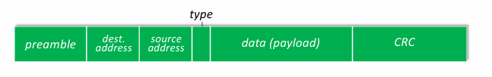
- Preamble (8 bytes):
  - Used by the receiver's NIC to synchronize its clock with the sender's clock.
- Destination & Source Addresses MAC (6 bytes each):
  - These are the 48-bit MAC addresses of the destination and source NICs.⁸
  - A NIC will pass the frame up to the network layer if the destination address:
    - Matches its own MAC address, OR
    - Is the broadcast address (FF-FF-FF-FF-FF-FF), e.g., for an ARP query.
  - If there is no match, the NIC discards the frame.
- Type (2 bytes):
  - higher-layer (Layer 3) protocol encapsulated in the payload (e.g., 0x0800 = IP, 0x0806 = ARP)
  - This field is used by the operating system to demultiplex the payload, i.e., pass it to the correct L3 protocol handler.
- Data (Payload) (46-1500 bytes):
  - Contains the encapsulated L3 packet (e.g., an IP datagram).¹¹
- CRC (4 bytes):
  - Cyclic Redundancy Check used for error detection.¹²
  - If the receiver computes the CRC and it doesn't match the value in this field, an error is detected and the frame is dropped.

Ethernet: Unreliable, Connectionless Service
- Connectionless: No handshaking.
- Unreliable: receiving NIC does not send ACKs or NAKs to the sending NIC.
  - If a frame is dropped Ethernet does not attempt to recover it.
  - Recovery of lost data must be handled by a higher-layer reliable protocol, such as TCP.
- MAC Protocol: Ethernet's foundational MAC protocol (for shared media/bus) is unslotted CSMA/CD with binary backoff.¹³

802.3 Ethernet Standards
- Ethernet is defined by many IEEE 802.3 standards.¹⁴
- Commonalities: All standards share the common MAC protocol and frame format.¹⁵
- Differences: They specify different speeds (10 Mbps, 1 Gbps, 10 Gbps, 40 Gbps, etc.) and different physical layer media (e.g., copper cable, different types of fiber optic).¹⁶
- This separation allows Ethernet (Layer 2) to run over any new physical layer (Layer 1) technology.

- Switches
Ethernet Switch
- Operation:
  - It's a store-and-forward device: it buffers an entire incoming frame before deciding where to send it.
  - It examines the destination MAC address of each frame.
  - It selectively forwards the frame only to the specific output interface that leads to the destination, unlike a hub which broadcasts to all ports.
- Key Features:
  - Transparent: Hosts on the network are unaware of the switch's presence.
  - Plug-and-Play / Self-Learning: no manual configuration require.

Switch Benefits (vs. Hubs/Bus)
- Dedicated Links: Hosts have a dedicated, direct connection to a switch port.
- Collision Elimination:
  - Each link - own separate collision domain.
  - Since (in modern networks) only one host is on each link, collisions are eliminated.
  - This allows for full-duplex communication (sending and receiving at the same time).
- Simultaneous Transmissions:
  - Switches can forward multiple frames in parallel, if they don't contend for the same output port.
  - Example: Host A can send to Host A' at the same time that Host B sends to Host B'.
  - Contention: If Host A and Host C both try to send to Host A' simultaneously, the switch must buffer one frame and send them sequentially.

The Switch Forwarding Table
- Purpose: This table (also called a MAC table) is how the switch knows which port to use to reach a specific host.
- Structure: Each entry in the table contains:
  - A host's MAC address.
  - The switch interface (port) that leads to that MAC address.
  - A timestamp (TTL), which is used to age out and remove old, stale entries.

The Switch Algorithm (Self-Learning & Forwarding)
A switch follows a simple algorithm for every frame it receives on an interface (e.g., Port X):
- Learn (Inspect Source):
  - The switch looks at the frame's source MAC address (MAC_S).
  - It records in its forwarding table that MAC_S is reachable via Port X. It also updates the timestamp for that entry.
- Lookup (Inspect Destination):
  - The switch looks at the frame's destination MAC address (MAC_D).
  - It searches its forwarding table for MAC_D.
- Forward / Filter / Flood (The Decision):
  - Case 1: Entry Found (Forward): If MAC_D is in the table and associated with a different port (e.g., Port Y), the switch forwards the frame only out of Port Y.
  - Case 2: Entry Found (Filter): If MAC_D is in the table and associated with the same port the frame came from (Port X), the switch drops the frame. This prevents looping and is called filtering.
  - Case 3: Entry Not Found (Flood): If MAC_D is not in the table (the switch doesn't know where it is), the switch floods the frame. This means it sends a copy out of all ports except the one it arrived on (Port X).

Interconnecting Switches
- Switches can be connected to each other to build larger networks.
- The self-learning algorithm works exactly the same way.
- A switch (S1) will simply learn that all hosts connected to another switch (S2) are reachable via the single port that links S1 to S2.

Real-World Example (UMass Network)
- Large campus networks show the scale of switching: a single network can have thousands of switches and tens of thousands of wired/wireless devices.
- These networks are hierarchical, using L2 switching at the "building" or "access" layer, and L3 routing (using protocols like IS-IS and BGP) at the "core" and "border" layers.

⚡ Switches vs. Routers
This is a key comparison:
Feature | Switches | Routers
Operates at | Layer 2 (Link Layer) | Layer 3 (Network Layer)
Examines | MAC Addresses (in the frame header) | IP Addresses (in the datagram header)
Primary Goal | Move frames within a single LAN/subnet. | Forward datagrams between different networks.
Table Name | Forwarding Table (or MAC Table) | Routing Table
How Table is Built | Self-learning (by observing frame source MACs) | Routing Algorithms (e.g., OSPF, IS-IS, BGP) by communicating with other routers.

- VLANs
Virtual LANs (VLANs)
1. Motivation for VLAN
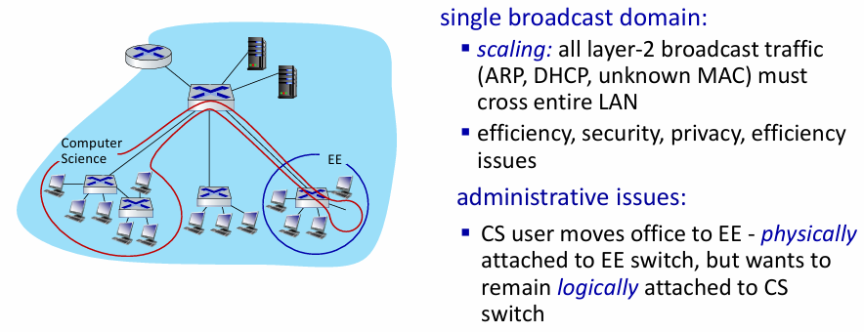

2. Port-Based VLANs
- Definition: A VLAN allows a single physical switch to be configured to operate as multiple, separate virtual switches.
- 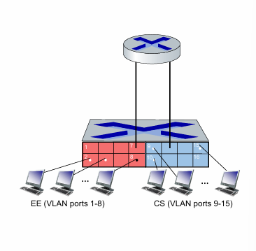
- Traffic Isolation:
  - Traffic from ports 1-8 can only reach other ports in that same VLAN (ports 1-8).
  - Traffic from ports 9-16 can only reach other ports in that same VLAN (ports 9-16).
  - Each VLAN becomes its own, separate broadcast domain.
- Forwarding Between VLANs: need Router layer 3
- Other VLAN Types: VLANs can also be defined by device MAC addresses instead of switch ports.
- Dynamic Membership: Ports can be easily and dynamically re-assigned between VLANs via software.

3. VLANs Spanning Multiple Switches
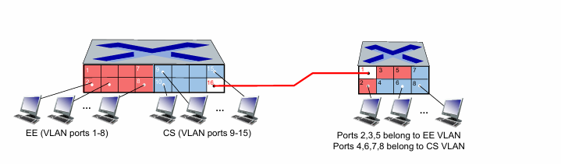
- A single VLAN (like the "CS VLAN") can span multiple physical switches.
- Trunk Port: A special switch port configured to carry traffic for multiple VLANs between switches.
- The Problem: A standard Ethernet frame has no field to indicate which VLAN it belongs to.
- The Solution (802.1Q): A protocol that adds a "tag" (an extra header field) to frames as they cross a trunk port. This tag identifies the frame's VLAN.

- 802.1Q VLAN Frame Format
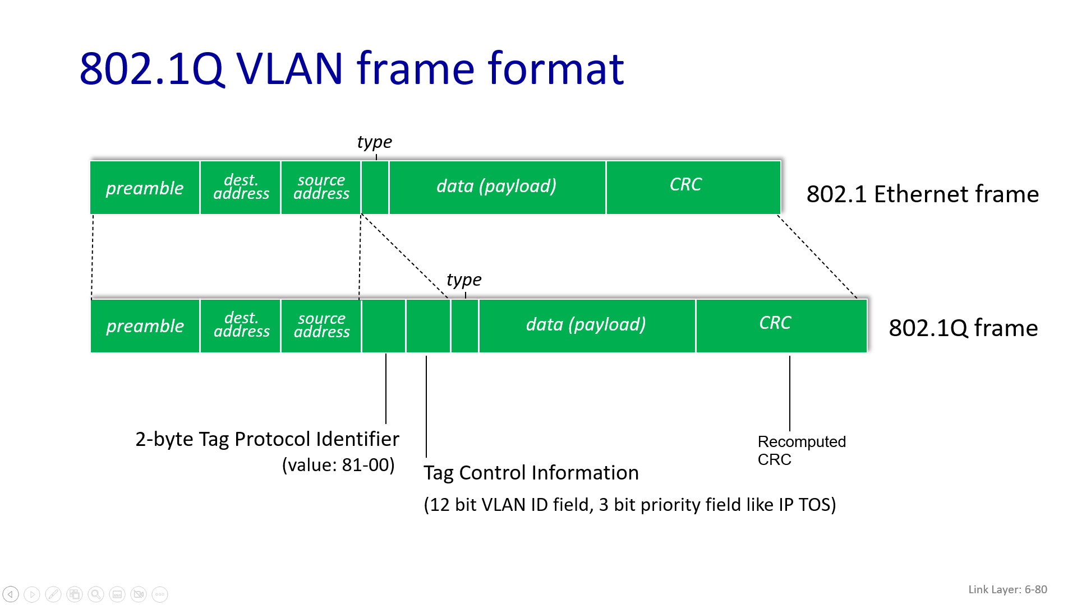

5. EVPN (Ethernet VPNs) / VXLAN
- Use Case: Allows servers in two geographically separate data centers (e.g., one in Sunnyvale, one in Bangalore) to act as if they are on the same local L2 subnet.
- Ethernet frames carried within IP datagrams between sites
- “tunneling scheme to overlay Layer 2 networks on top of Layer 3 networks ... runs over existing networking infrastructure ... provides a means to "stretch" a Layer 2 network.”
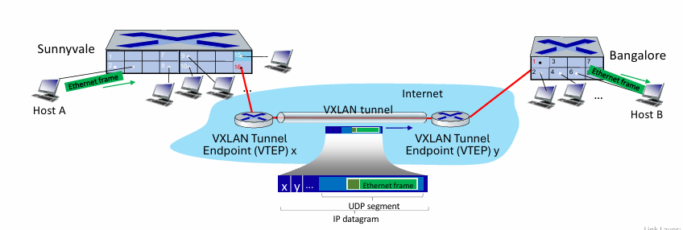
5.link virtualization: MPLS – packets are forwarded based on labels
Multiprotocol Label Switching (MPLS)
- Goal: To achieve high-speed IP forwarding using a fixed-length label for lookups instead of the slower, more complex "longest prefix matching" required for IP addresses.
- Concept: It borrows ideas from the Virtual Circuit (VC) approach. It's often called a "Layer 2.5" protocol.
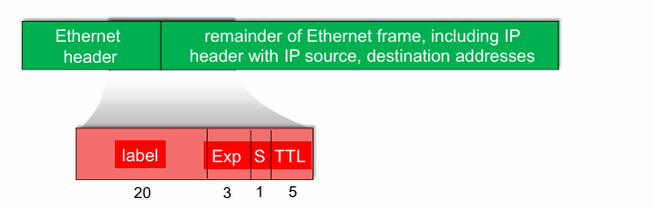

MPLS-Capable Routers
- Also known as Label-Switched Routers (LSRs).
- They forward packets based only on the MPLS label value, without inspecting the IP address.
- Each LSR maintains a separate MPLS forwarding table (often called a Label Information Base, or LIB) which is distinct from its standard IP forwarding (routing) table.

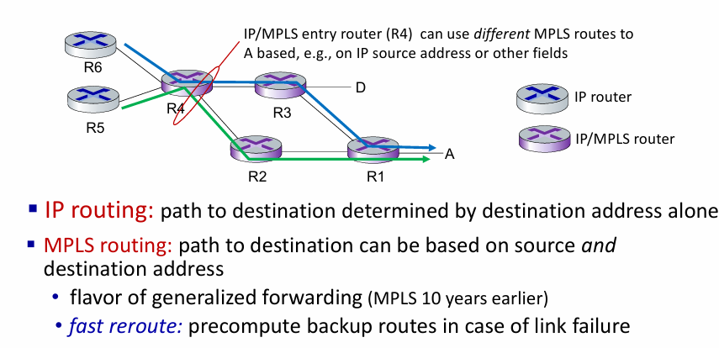
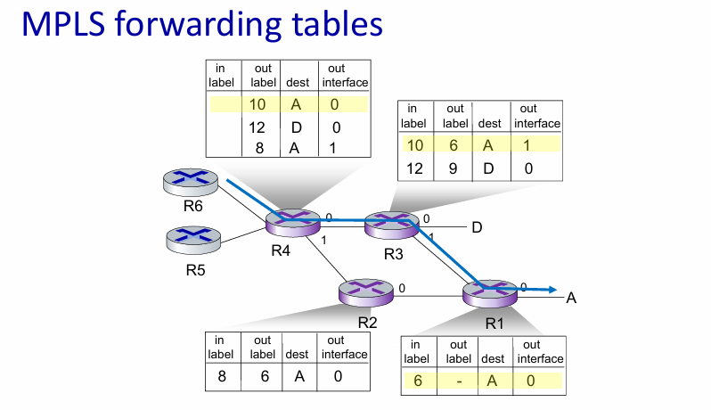

6. data center networking
Datacenter Networks
- Definition: Networks containing 10s to 100s of thousands of closely coupled hosts located in close proximity.
- Examples: Used for e-business (Amazon), content servers (YouTube, Apple), and search engines/data mining (Google).
- Core Challenges:
  - Handling multiple applications, each serving a massive number of clients.
  - Ensuring high reliability.
  - Managing and balancing load to avoid processing, networking, and data bottlenecks.

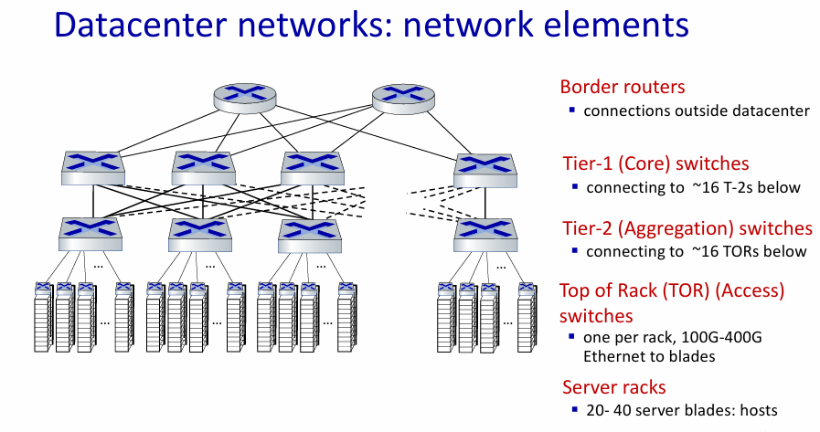
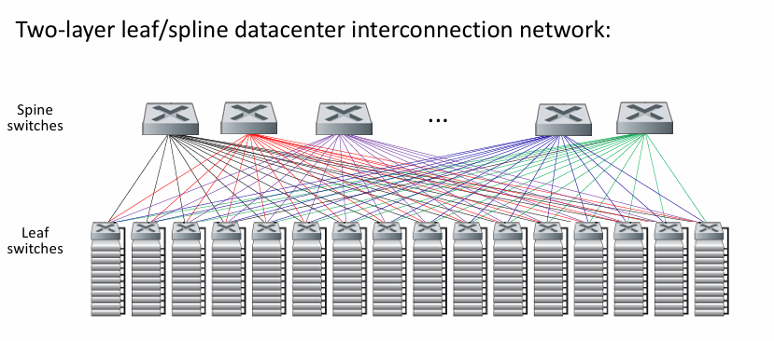

Datacenter networks: multipath ▪
- rich interconnection among switches, racks:
- increased throughput between racks (multiple routing paths possible)
- increased reliability via redundancy
Application-Layer Routing (Load Balancer)
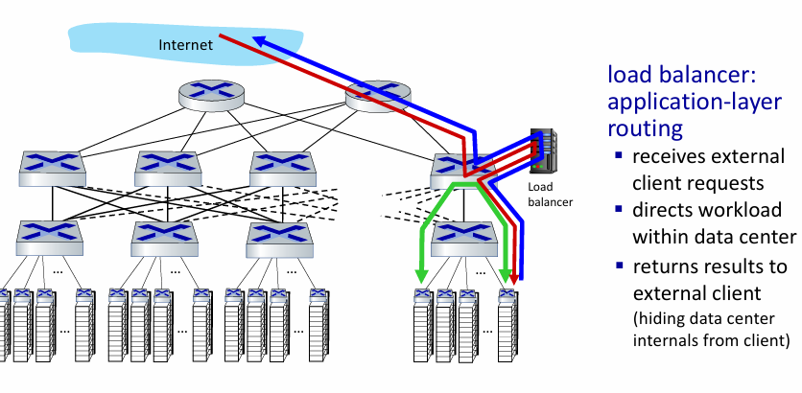

Example: Google's ORION
- ORION is Google's SDN control plane that manages both its internal datacenter (Jupiter) and its Wide Area Network (B4).
- Key Architecture:
  - Routing (iBGP, traffic engineering) is not a distributed protocol but is implemented as applications running on top of the central ORION core.
  - Uses edge-to-edge flow-based controls to meet specific application performance (SLA) contracts.
  - It uses OpenFlow for signaling to switches and a pub-sub model for its distributed microservices.
- Radical Shift: This model removes routing protocols (like OSPF) from the switches themselves. Routing and even parts of congestion control are managed by the centralized SDN controller, leading to the question of whether traditional, distributed protocols are "dying" in these environments.

7. a day in the life of a web request
Here are the short notes summarizing the flow of a web request from connection to page display.
1. Network Configuration (DHCP)
- Goal: Client laptop needs an IP address, Default Gateway IP, and DNS Server IP.
- Action: Client broadcasts a DHCP Discover message (UDP/IP/Ethernet).
- Response: DHCP Server sends a DHCP ACK containing the required IP configuration.
- Result: Client is now configured for the network.
2. Gateway Resolution (ARP)
- Goal: Client needs the MAC address of the Router (Gateway) to send packets outside the local network.
- Action: Client broadcasts an ARP Query ("Who has [Router IP]?").
- Response: Router sends a unicast ARP Reply ("I am [Router IP], my MAC is [Router MAC]").
- Result: Client can now encapsulate packets destined for the internet into Ethernet frames addressed to the Router.
3. Finding the Server (DNS)
- Goal: Resolve the domain name www.google.com into an IP address.
- Action: Client sends a DNS Query to the DNS Server IP (packet is routed via the Gateway).
- Response: DNS Server replies with Google's IP address (e.g., 64.233.169.105).
- Result: Client knows the specific destination IP for the web server.
4. Establishing Connection (TCP)
- Goal: Create a reliable, connection-oriented session with Google's server.
- Action: Client initiates the 3-Way Handshake:
  - Client sends SYN.
  - Server responds with SYN-ACK.
  - Client sends ACK.
- Result: A logical connection is established between Client and Google.
5. Fetching Content (HTTP)
- Goal: Request and display the web page.
- Action: Browser sends an HTTP GET request through the established TCP connection.
- Response: Google server sends an HTTP Reply (Status 200 OK) containing the HTML code.
- Result: Browser renders the HTML and displays www.google.com.

